Task 1:

Check whether /user/acadgild directory exists or not in the HDFS.

If it doesn't exist, then create this.

Create a directory /user/acadgild/hadoop.

Created directory as shown in below screen shot:

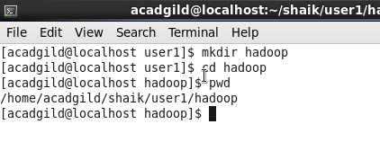

Task 2:

Create a file in HDFS under directory /user/acadgild/hadoop, with name word-count.txt.

Whatever we type on screen should get appended to the file.

Try to type (on screen) few lines from any online article or textbook.

Created a file in the directory and there is come content you can check in below screen shot:

